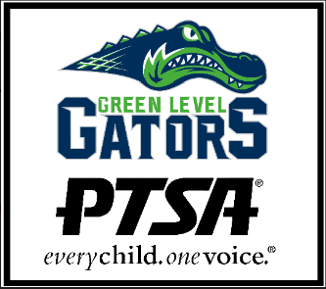
Green Level High School PTSA
Student Club Grant Application

In order to support the Student Clubs of Green Level High School, the PTSA is pleased to offer grant opportunities to help these groups secure additional funding.

Grant Requirements
- All grant expenses must relate to the mission and vision of the club.
- “Celebration Items” are not permitted (no funding for “end of year” parties).
- Registration fees or supplies for community-wide events are eligible up to $150/club.
- Each club is limited to one grant per school year.
- Grants must have a PTSA Sponsor (Sponsor must be a GLHS PTSA member and can be a faculty advisor, student, parent, etc.).
- Grants will be awarded while funds are available.

Grant Process
- Submit applications to Mr. Viens (jviens@wcpss.net) for administration review and approval. Mr. Viens will submit the application to the PTSA.
- The PTSA will notify applicants of grant status via email so please be sure to provide club contact email(s).
- Once grant is approved, applicants must submit the receipt(s). The PTSA will reimburse the applicants according to standard GLHS PTSA reimbursement process.

Please email glhs.ptsa.grants@gmail.com for application status and questions.

Club Grant Application

Club Name
Advisor Name, Email & Signature
Treasurer Name & Email
Another Club Officer Name, Position & Email
PTSA Sponsor
Amount Requested, Check Payee, and Payee Address (if applicable)
How will these funds be used to benefit your Club?
Please include the following information:
- Name and date of the event
- # of people attending from GLHS
- List of items your group intends to purchase

Required Administration Approval & Date: ______________________________________________
PTSA Approval/Date: ____________________ Receipt/Invoice Received:__________________
Funds Paid to: __________________________ Date Funds Paid: _________________________

